**Jai Hind Educational Trust’s**

**ZULAL BHILAJIRAO PATIL COLLEGE, DHULE.**

**Department of Commerce & Management**



**A Project Report on**

**Stock BrokingSystem (StockPlus+)**

**For**

**Under Guidance of**

**(Name)**

**Submitted By**

**Darp Atharv Madhav**

**In partial fulfilment of the degree of**

**B.C.A (Bachelor of Computer Application)**

**AT**

**JAI HIND EDUCATION TRUST’S**

**ZULAL BHILAJIRAO PATIL COLLEGE, DHULE**

**NORTH MAHARASHTRA UNIVERSITY, JALGAON.**

**(Year: 2023 -2024)**

**Jai Hind Educational Trust’s**

**ZULAL BHILAJIRAO PATIL COLLEGE, DHULE.**

**Department of Commerce & Management**



**CERTIFICATE**

**This is to certify that Darp Atharv Madhav**

**Have successfully completed the project entire**

**“STOCK BROKING WEBSITE (StockPlus+)”**

**He has submitted the report in the partial fulfilment of the degree in BCA (Bachelor of Computer Application) in academic year 2023-2024.**

**(Name) (Name)**

**Project Guide Head of Department**

**Examiner Examiner**

**Place: Dhule.**

**Acknowledgement**

I would like to thank Prof. Dr .P. H. Pawar sir the Principal of Jaihind Educational Trust's **ZULAL BHILAJIRAO PATIL COLLEGE,DHULE** for his precious suggestion, motivation and support in the project report.

I would like to thank Asst. Prof. P. G. Adawadkar sir, Head,Faculty of Commerce and Management for providing an opportunity to learn through project report work, by the medium of project. I consider myself to be fortunate to get this opportunity to explore in the project report of “**Stock Broking Website**”. I am sincerely grateful to her for his valuable guidance, motivation and support at all stages of all project work, right from conception of idea to the finalization of project work and creating in a flexible and enjoyable environment to work.

I am thankful of Faculty of Commerce and Management for constant Inspiration in the pedagogical world of Bachelor of Computer Application.

**Atharv Darp**

**(T.Y.B.C.A.)**

***INDEX***

|  |  |  |
| --- | --- | --- |
| **Sr. No.** | **Content** | **Page No.** |
| **1** | **Introduction to Organization** | **5** |
| **2** | **Proposed and Existing System** | **6** |
| **3** | **Need Of Computerization** | **8** |
| **4** | **Introduction to Environment** | **9** |
| **5** | **Data Collection And Analysis** | **11** |
| **6** | **Hardware & Software Requirement** | **17** |
| **7** | **Feasibility Study** | **18** |
| **8** | **Entity Relationship Diagram** | **19** |
| **9** | **Dataflow Diagram** | **20** |
| **10** | **Data System Input & Output** | **22** |
| **11** | **Testing & Implementation** | **28** |
| **12** | **Suggestion & Conclusion** | **30** |

CHAPTER-I

**INTRODUCTION TO ORGANIZATION**

**Introduction About Organization:-**

**Name Of The Organization :- “Stock Broking Website”.**

**Location :- Dhule**

**Proprietor :- Atharv Darp**

**“Stock Broking Website”** is a dynamic entity committed to technological innovation and societal connection. With a vision to harness the power of digital communication, the organization embarks on a project to develop a cutting-edge Stock Broking Website.

Founded on principles of user-centric design and privacy, the organization strives to redefine the landscape of online social interaction.

Our Vision:

At Social Connect Hub, we envision a world where individuals can seamlessly connect, share, and collaborate in a digital space that prioritizes user-centric design, privacy, and cutting-edge features. We believe in the transformative potential of technology to bring people together, transcending geographical boundaries and enriching lives through meaningful interactions.

Mission Statement:

Our mission is to develop a state-of-the-art Stock Broking Website that goes beyond traditional platforms, offering users a dynamic and user-friendly space where they can express themselves, build communities, and engage with content that resonates with their interests. Social Connect Hub is committed to creating an inclusive and secure online environment that empowers individuals to connect authentically.

CHAPTER-II

**PROPOSED & EXISTING SYSTEM**

**Existing system:-**

The proposed stock broking website envisions a comprehensive platform for financial market enthusiasts, offering a streamlined experience in stock trading. Focused on user-centric design, the system will feature real-time market data, intuitive navigation, and advanced analytical tools to empower investors.

Security is paramount, with robust authentication measures and encrypted data transmission ensuring the protection of user information. The platform's versatility will support various order types, accommodating diverse trading strategies.

A responsive design will enable access across devices, enhancing user convenience. The project's roadmap includes continuous updates, incorporating user feedback to refine features and adapt to evolving market dynamics.

By providing a secure, user-friendly, and technologically advanced interface, the proposed stock broking website aims to not only meet but exceed the expectations of traders, fostering a dynamic and efficient trading environment.

**Proposed system:-**

The proposed stock broking website is a comprehensive platform designed to redefine the landscape of online stock trading. Our system prioritizes user experience, providing a feature-rich interface for investors to seamlessly engage in buying, selling, and monitoring stocks. Real-time market data, advanced charting tools, and personalized portfolios will empower users with the insights needed to make informed investment decisions.

Security is a paramount concern, with multi-layered authentication mechanisms, encrypted data transmission, and adherence to industry best practices.

Versatility is a key feature, supporting various order types to accommodate a range of trading strategies. The website will boast a responsive design, ensuring accessibility across multiple devices, fostering a convenient and flexible trading environment. Continuous improvement is integral to our approach, with plans for regular updates based on user feedback, market trends, and technological advancements.

By combining cutting-edge technology with user-centric design, our proposed stock broking system aspires to become a pioneering force, enhancing the overall trading experience and setting new standards in the online financial domain.

CHAPTER-III

 **NEED OF COMPUTERIZATION**

The need for computerization in various sectors is paramount in the contemporary era, driven by the transformative power of technology to enhance efficiency, accuracy, and overall operational effectiveness. In the financial domain, like stock broking, computerization is indispensable. Automation of trading processes through computer systems significantly reduces manual errors and ensures swift execution of transactions in real-time.

Computerization facilitates the seamless handling of vast amounts of financial data, enabling quick analysis and decision-making. In the stock broking context, where timely and accurate information is crucial, computerized systems provide real-time market data, charts, and analytics, empowering investors to make informed choices.

Moreover, computerization enhances security measures, ensuring the integrity and confidentiality of sensitive financial information. With robust authentication mechanisms, encryption protocols, and secure data storage, computerized systems mitigate the risks associated with unauthorized access and data breaches.

Efficient record-keeping and management are additional advantages of computerization. Automation of administrative tasks, documentation, and compliance procedures streamlines operations, reducing paperwork and improving overall organizational productivity.

In conclusion, computerization is imperative in the stock broking industry as it not only amplifies efficiency and accuracy but also introduces a level of sophistication that is essential in navigating the dynamic and data-intensive landscape of financial markets. Embracing computerization is not just a choice but a strategic necessity for organizations aiming to stay competitive and provide optimal services in the rapidly evolving world of finance.

CHAPTER-IV

 **Introduction to Environment**

The technological environment in which a Stock Broking Website operates is a dynamic and interconnected ecosystem, comprising various web development languages and technologies. Understanding this environment is fundamental to the creation of a robust, interactive, and data-driven social media platform. Here's an introduction to the environment, highlighting the key technologies involved:

1. HTML (HyperText Markup Language):

HTML serves as the foundation of the Stock Broking Website's structure. It defines the layout and organization of content, allowing for the creation of user interfaces, profiles, posts, and other essential elements. HTML5, with its enhanced multimedia capabilities, is particularly crucial for supporting a rich and dynamic user experience.

2. CSS (Cascading Style Sheets):

CSS is employed to style and visually enhance the elements created with HTML. It governs the website's appearance, including color schemes, fonts, layouts, and responsive design. CSS ensures a cohesive and visually appealing presentation across various devices and screen sizes.

3. PHP (Hypertext Preprocessor):

PHP is a server-side scripting language that powers the backend functionality of the Stock Broking Website. It enables dynamic content generation, user authentication, and database interactions. PHP plays a vital role in processing user requests, managing sessions, and ensuring the secure execution of server-side operations.

4. JavaScript:

JavaScript is a client-side scripting language that enhances the interactivity of the social media platform. It enables the creation of dynamic features, such as real-time updates, interactive forms, and asynchronous communication. JavaScript, when used with frameworks like React or Angular, contributes to a more responsive and engaging user interface.

5. MySQL:

MySQL is a relational database management system used for storing and retrieving data efficiently. In the context of a Stock Broking Website, MySQL is crucial for managing user profiles, posts, comments, and other relational data. It ensures the integrity and reliability of the data storage system.

6. Security Measures:

Security considerations are paramount in the web development environment. Technologies such as HTTPS, secure PHP coding practices, and client-side validation using JavaScript are essential for protecting user data, ensuring secure logins, and preventing common web vulnerabilities.

7. AJAX (Asynchronous JavaScript and XML):

AJAX is employed to facilitate asynchronous communication between the browser and the server. This enables real-time updates, reducing the need for page reloads. AJAX, often used with JavaScript, contributes to a more dynamic and responsive user experience on the Stock Broking Website.

In summary, the technological environment for a Stock Broking Website is a synergistic blend of HTML, CSS, PHP, JavaScript, MySQL, and other supporting technologies. A successful social media platform requires a comprehensive understanding of these technologies to create an engaging, secure, and user-friendly online environment.

CHAPTER-V

 **DATA COLLECTION & ANALYSIS**

**DATA DICTIONARY**

A data dictionary is ‘metadata’ is i.e. about data. Data dictionary is list of all data element composing the data flowing thought a system major complaint are data flow, data stores and stores process. I have tried my level best to conserve storage space in this project. Even though there is a large amount of data element on proposed system. Still there is fountain system. The following section gives of detail element.

* **Database Name: demat_account (User Table)**

**Purpose: To Store the information about the User**

|  |  |  |  |  |  |
| --- | --- | --- | --- | --- | --- |
| **id** | **First Name** | **Last Name** | **City** | **Pan Number** | **Mobile Number** |
| **1** | **Atharv** | **Darp** | **Dhule** | **DEK45E** | **78952545** |
| **2** | **Mahesh** | **Lakade** | **Pune** | **DJEHH5** | **94216787** |
| **3** | **Vijay** | **Patil** | **Hydrbad** | **LOEK45** | **57223761** |
| **4** | **Harshal** | **Sonwane** | **Mumbai** | **UT5D1S** | **21404922** |

|  |  |  |  |  |  |
| --- | --- | --- | --- | --- | --- |
| **Age** | **Funds** | **Occupation** | **Photo** | **Email** | **Password** |
| **15** | **$634** | **Student** | **Img.png** | [**abc@gmail.com**](mailto:abc@gmail.com) | **F$323R** |
| **25** | **$123** | **Other** | **Dko2.jpg** | [**Sdfkjh@gmail.com**](mailto:Sdfkjh@gmail.com) | **L$893F** |
| **46** | **$846** | **Student** | **54652.jpeg** | [**Jhd@gmail.com**](mailto:Jhd@gmail.com) | **DKL%** |
| **26** | **$53** | **Business** | **Gsd654.png** | **Eoljk@gmail.com** | **M41#F** |

* **Database Name: Portfolio (Portfolio Table)**

**Purpose: To Store the information about blocked_user.**

|  |  |  |  |  |
| --- | --- | --- | --- | --- |
| **Stock Name** | **Qunatity** | **Term** | **Date** | **Stock_price** |
| **AMZN** | **12** | **Long-Term** | **2022-12-23** | **$250** |
| **GOLD** | **46** | **Short- Term** | **2021-03-12** | **$156** |
| **NETFLIX** | **52** | **Long-Term** | **2023-01-01** | **$55** |

* **Database Name: SiP (SIP Table)**

**Purpose: To Store the user comments.**

|  |  |  |  |  |
| --- | --- | --- | --- | --- |
| Investment Amount | Investment Type | Exp Return | Investment Period | Inflation |
| 1 | Weekly | 12% | 11 Yrs | None |
| 2 | Yearly | 96% | 10 Yrs | 8% |
| 3 | Weekly | 36% | 5 Yrs | 6% |
| 4 | Quaterly | 100% | 30 Yrs | None |
| 5 | Monthly | 36% | 2 Yrs | 15% |

* **Database Name: Trade (Intraday Trade Table)**

**Purpose: To Store the information about followers list.**

|  |  |  |  |  |  |
| --- | --- | --- | --- | --- | --- |
| **Date** | **Amount** | **Qty** | **Pnl** | **Funds** | **Order_type** |
| **2022-12-22** | **$852** | **12** | **-$562** | **$896541** | **Limit** |
| **2021-08-25** | **$243** | **2** | **+$201** | **$96341** | **Market** |
| **2018-06-15** | **$826** | **9** | **+$466** | **$54554** | **Slm** |

* **Database Name: User_dashboard (User Panel)**

**Purpose: To Store the information about likes.**

|  |  |  |  |
| --- | --- | --- | --- |
| User_id | Funds | Pnl | Brockerage |
| 1 | $52 | -$545 | $200 |
| 2 | $656 | -$36 | $10 |
| 3 | $46 | +$56 | $22 |

|  |  |  |  |
| --- | --- | --- | --- |
| Affelete Name | No of Affeletes | Account Type | Account Opening Data |
| Andrew Tate | 0 | Standerd | 2021-12-06 |
| Rakesh Dasnor | 3 | Gold | 2000-04-06 |
| Anmol Jaiswal | 4 | Premium | 1998-05-30 |

CHAPTER-VI

 **HARDWARE & SOFTWARE**

Creating a Stock Broking Website involves a combination of hardware and software components to ensure optimal performance, security, and scalability. Here's a general overview of the requirements:

**Hardware Requirements:**

The organization will need the following minimum hardware requirement.

**Processor :-** **Minimum Intel Core I 3 Or its equivalent processor.**

**RAM**  :- **Minimum of 4 GB RAM**

**Backup drive** :-**Pen Drive**

**Hard drive** :-**Minimum of 512 GB**

**Monitor** :-**Minimum 14” Color Monitor.**

**Mouse** :- **A ps/2 or Serial Mouse.**

**Printer**  :- **80 Column Dot Matrix Printer.**

**Keyboard**  :- **105 Key Keyboard.**

With above configuration my system will run fast, if higher configuration is available then it will be good.

**Software requirements:-**

**Operating system** **:-** Windows 10

**Front end entry :-** VS Code

**Back end entry :-** PhpMyAdmin

CHAPTER-VII

 **FEASIBILITY STUDY**

A feasibility study is a crucial step in the early stages of planning for a project. It assesses the practicality, viability, and potential success of a proposed project or business venture. Here are key components typically included in a feasibility study:

1. Project Description:

- Clearly define the project, its objectives, and scope.

- Provide background information on the industry, market, and the need the project aims to fulfill.

2. Market Feasibility:

- Analyze the target market and its size.

- Evaluate demand for the product or service.

- Assess the competition and potential market share.

3. Technical Feasibility:

- Examine the technological requirements of the project.

- Assess the availability of necessary technology and expertise.

- Identify potential technical challenges and risks.

4. Financial Feasibility:

- Estimate the project's initial and ongoing costs.

- Project potential revenue and returns on investment.

- Conduct a thorough financial analysis, including cash flow projections and return on investment calculations.

5. Operational Feasibility:

- Assess how well the project aligns with existing processes and operations.

- Identify potential operational challenges and solutions.

- Evaluate the impact on day-to-day activities.

6. Legal and Regulatory Feasibility:

- Examine legal requirements and regulations relevant to the project.

- Assess potential legal challenges or obstacles.

- Ensure compliance with local, regional, and national laws.

7. Environmental Feasibility:

- Evaluate the environmental impact of the project.

- Assess potential risks and propose mitigation strategies.

- Ensure alignment with environmental regulations and standards.

8. Risk Analysis:

- Identify potential risks and uncertainties associated with the project.

- Develop risk mitigation strategies.

- Evaluate the impact of risks on project success.

9. Conclusion and Recommendations:

- Summarize findings and conclusions from each feasibility aspect.

- Provide a recommendation on whether to proceed with the project, modify it, or abandon it.

A comprehensive feasibility study helps stakeholders make informed decisions by providing a thorough understanding of the project's potential challenges, opportunities, and overall viability.

CHAPTER-VIII

 **ENTITY RELATIONSHIP DIAGRAM**

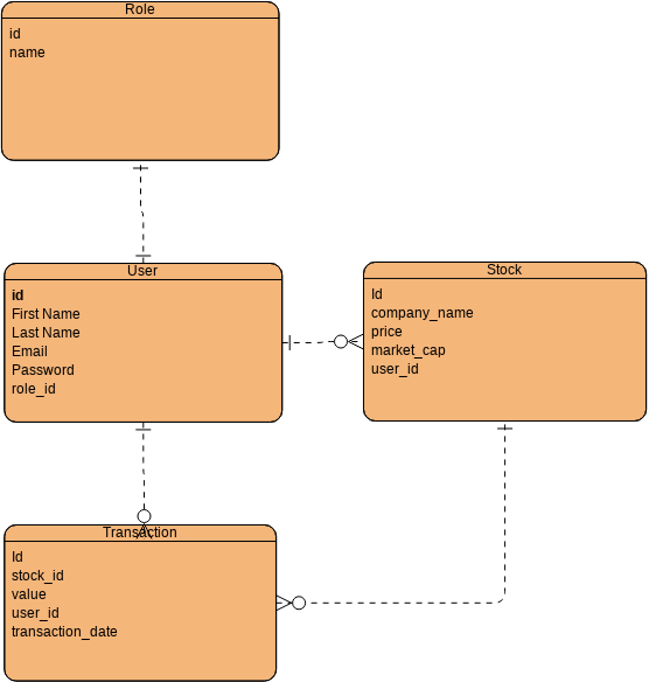

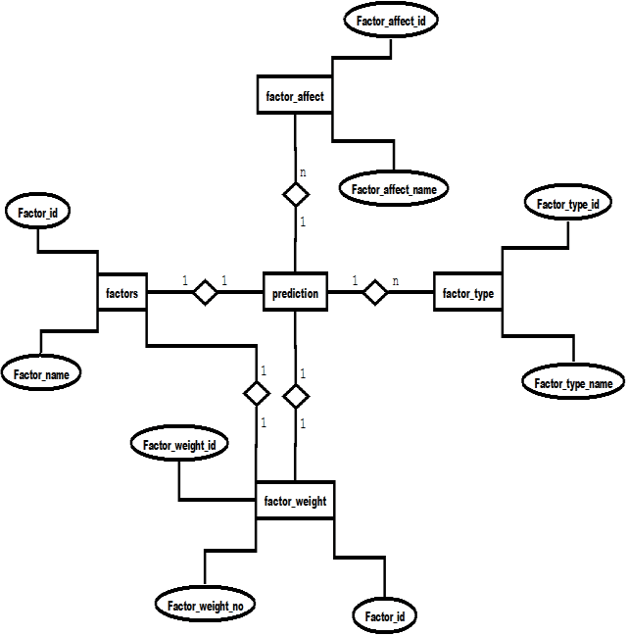

CHAPTER-IX

 **DATA FLOW DIAGRAM** 

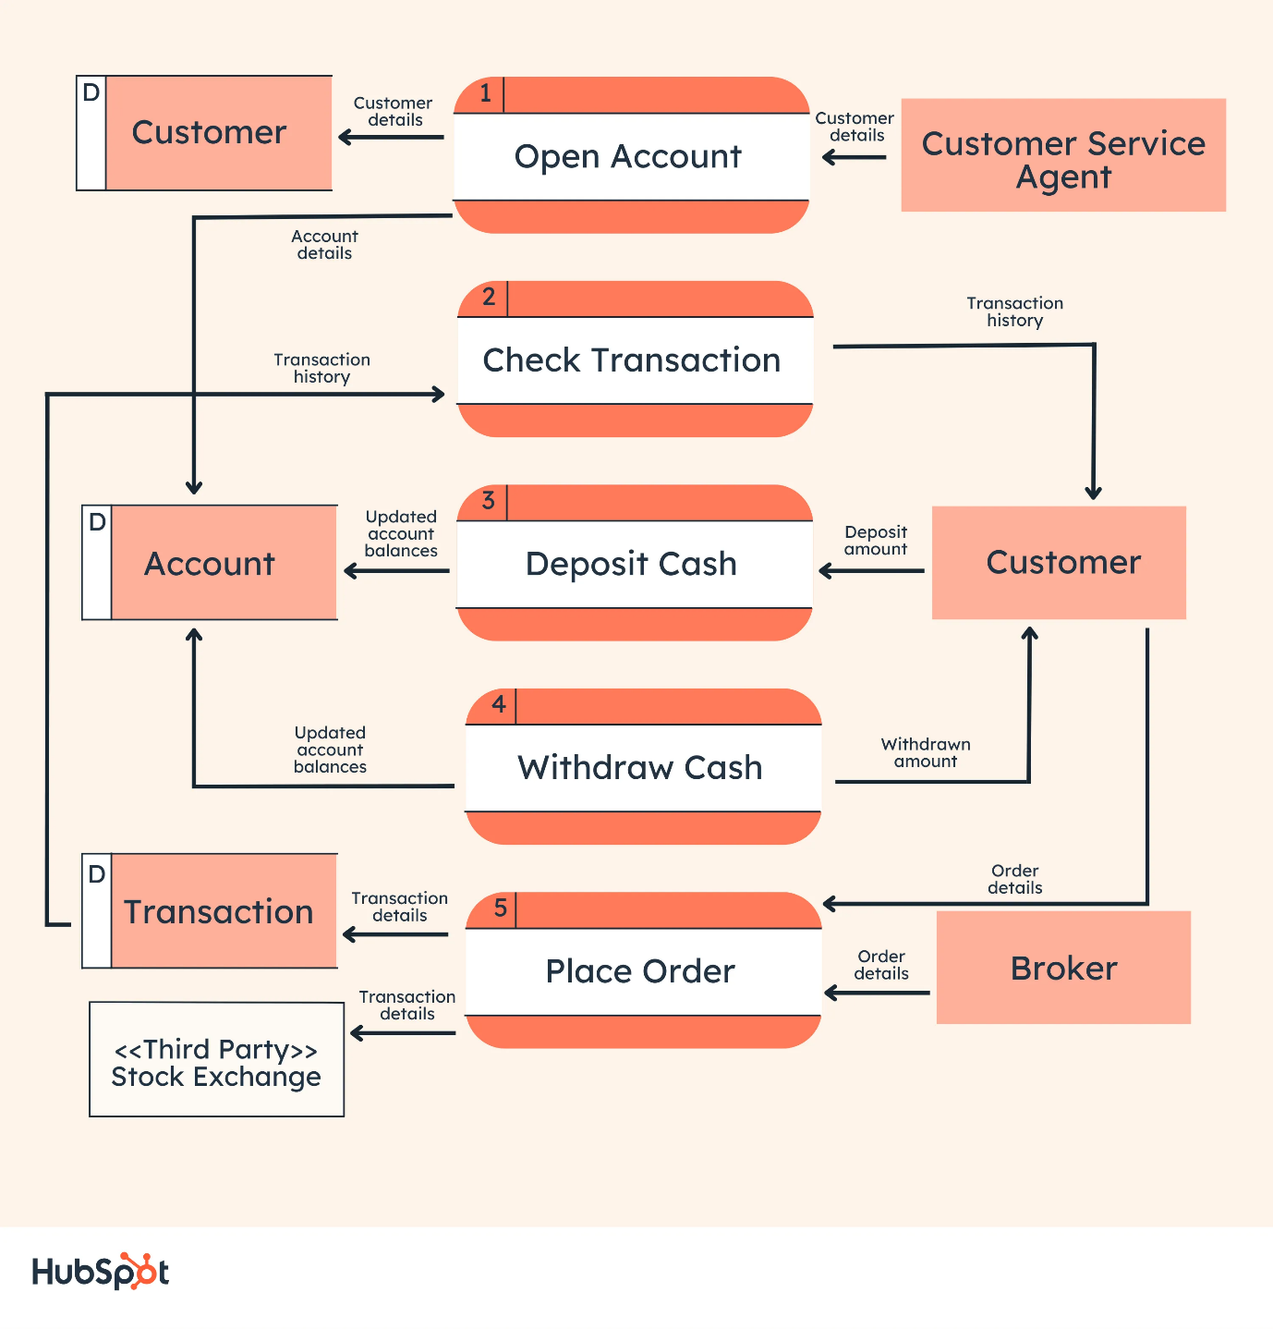

CHAPTER-X

 **DATA SYSTEM INPUT & OUTPUT**

**INPUT LAYOUTS**

**1) Signup Form :-**

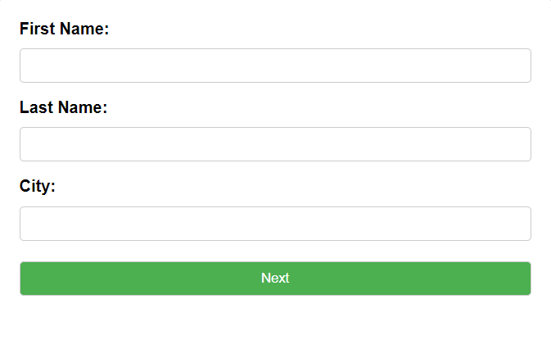

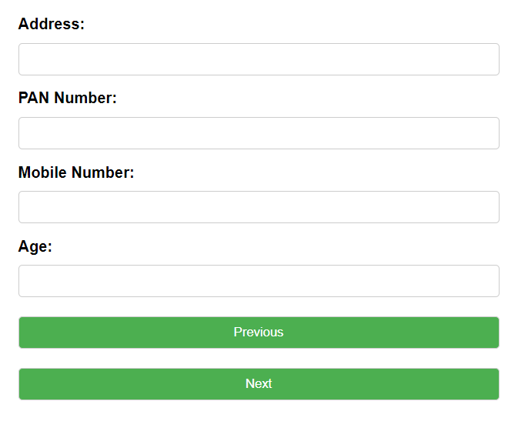

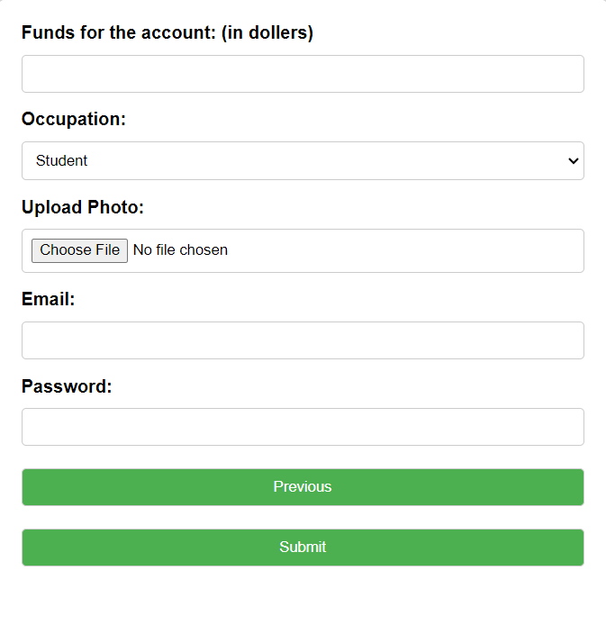

**2) Login Form :-**

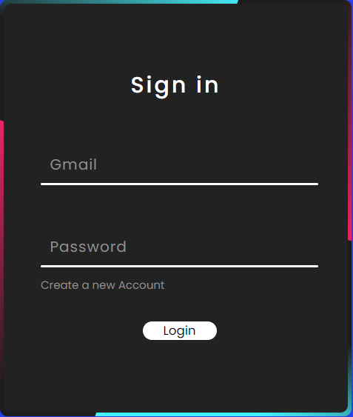

**4) Add New Stock in Portfolio:-**

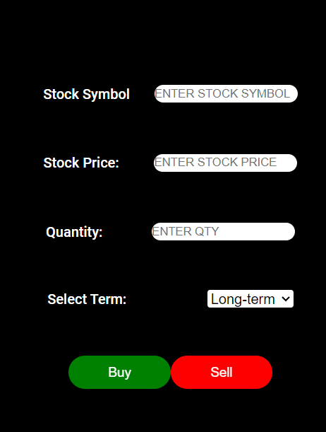

**5) Live Trading Panel :-**

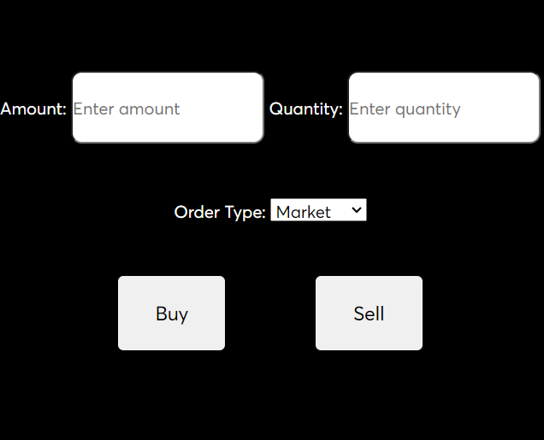

**6) Sip Create Form :-**

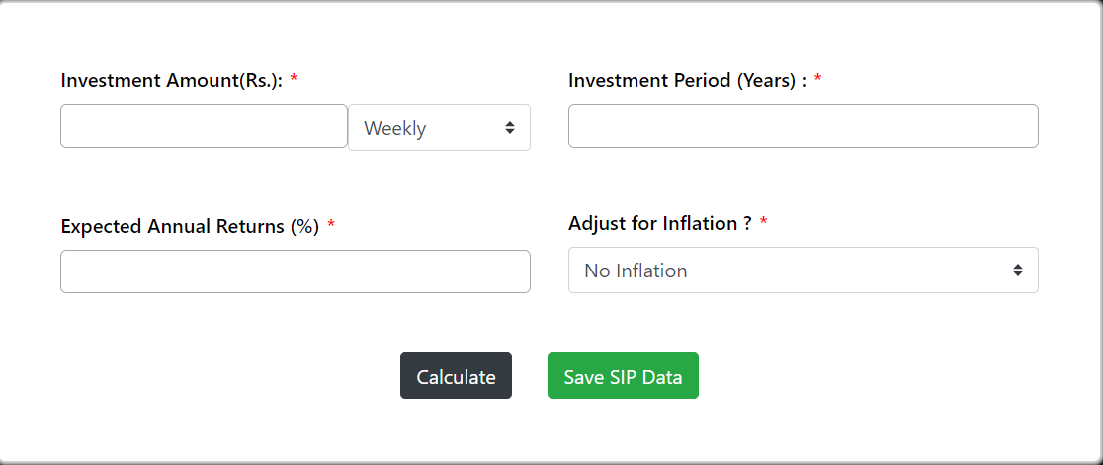

**7)Add New Funds Form :-**

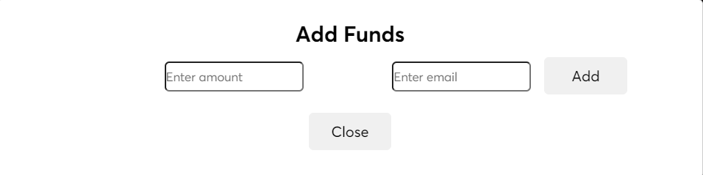

OUTPUT

**1)Home Page:-**

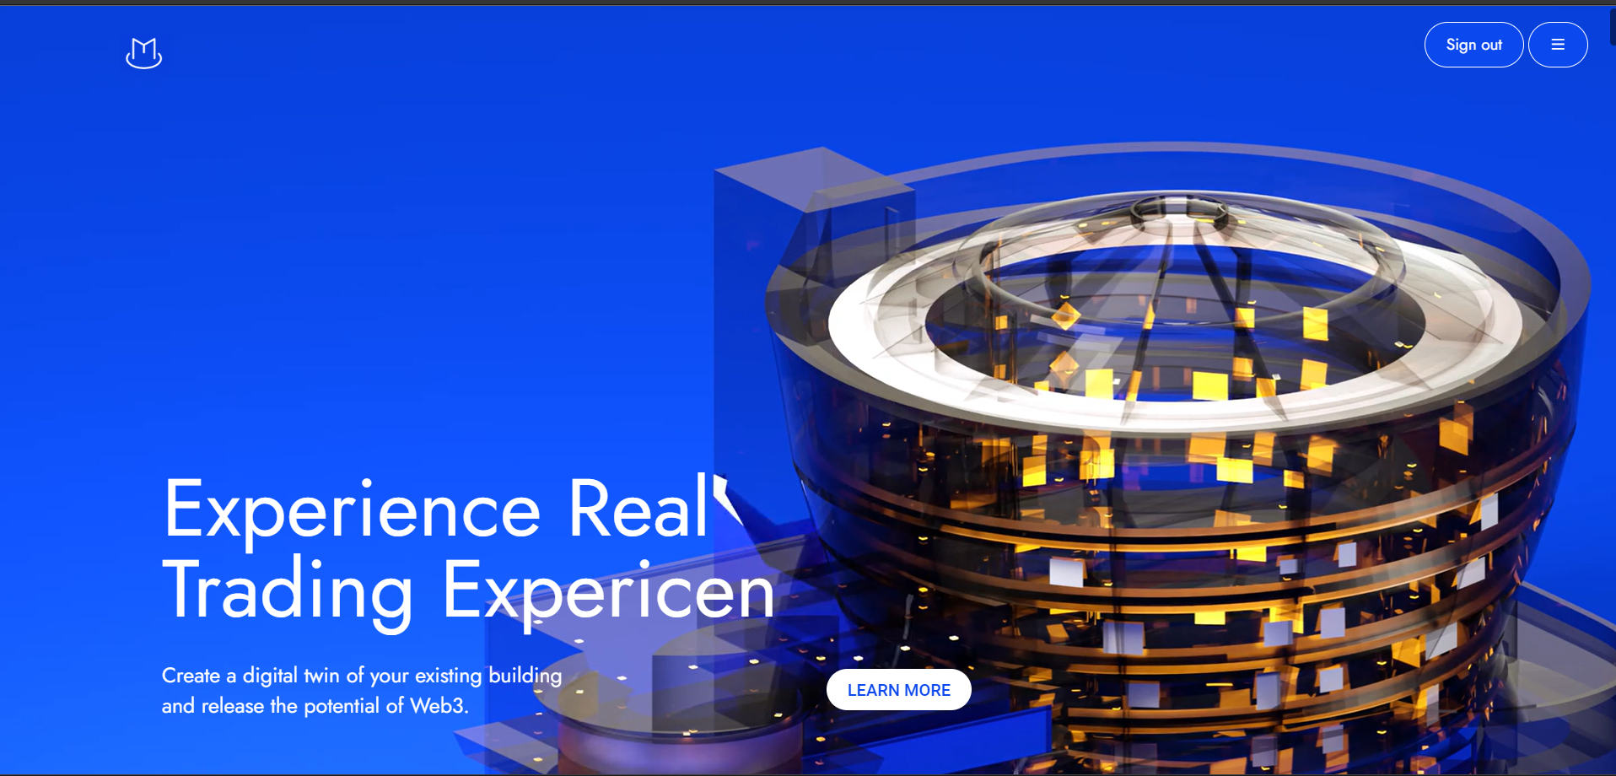

**2) News Section :-**

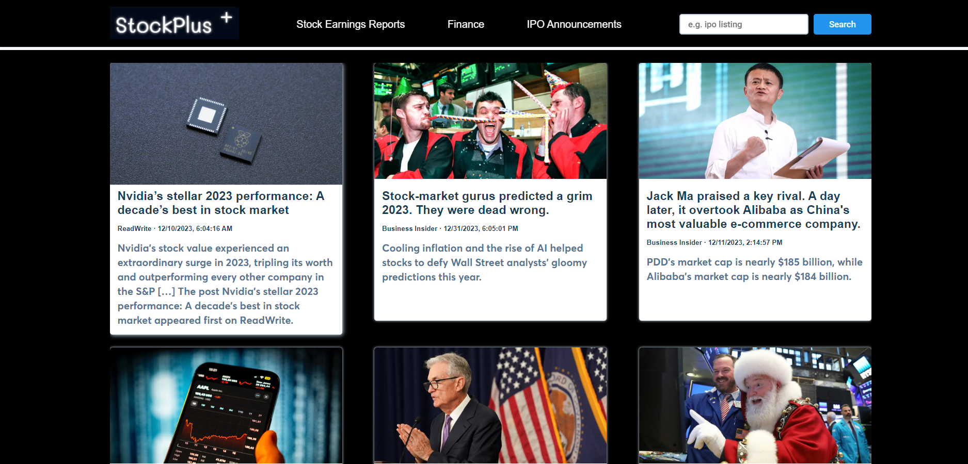

**3) User Dashboard Page :-**

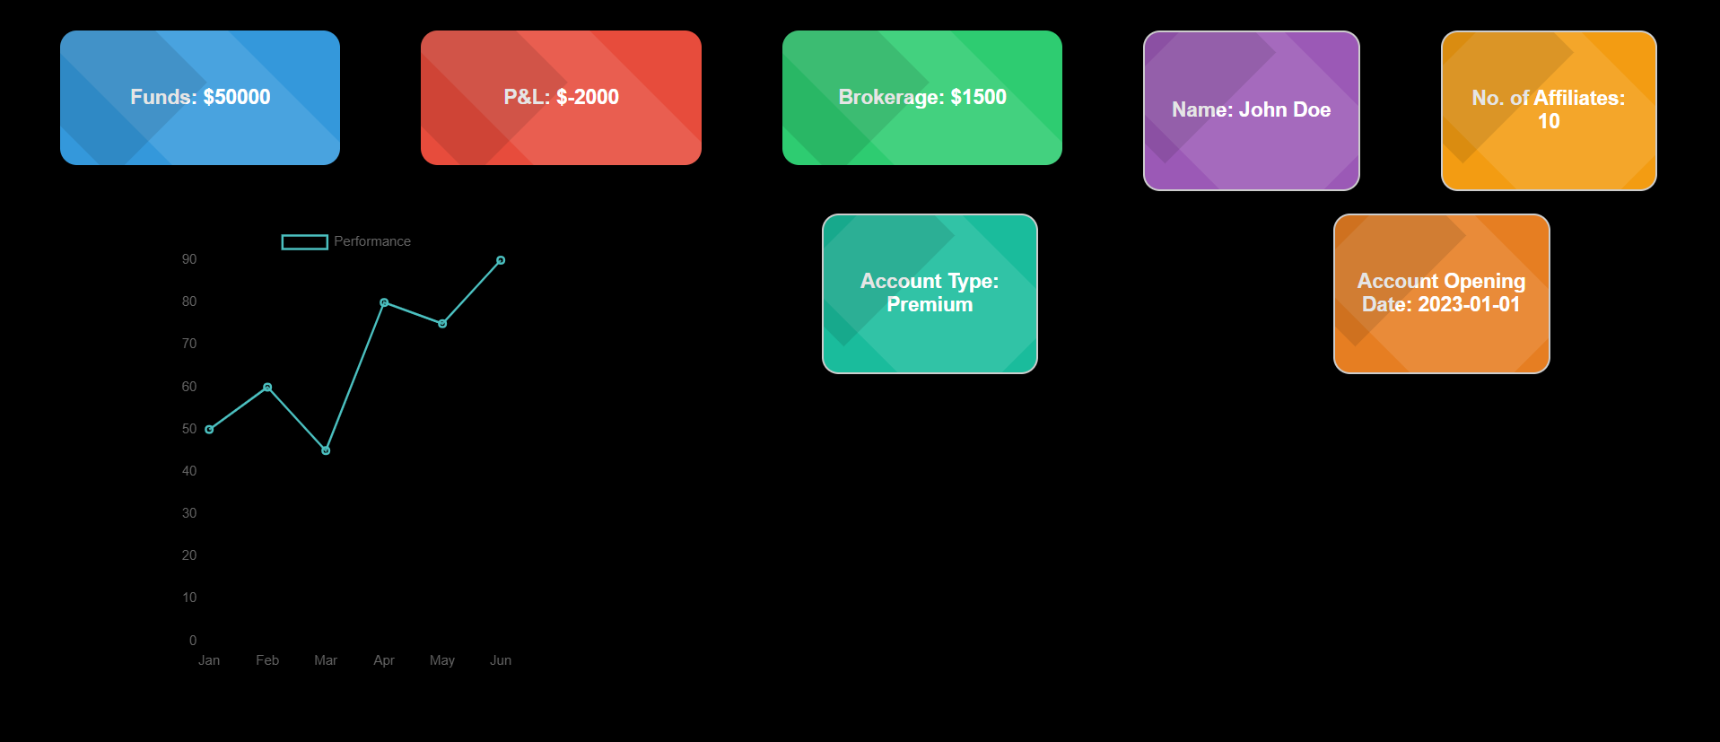

**4) Reports :-**

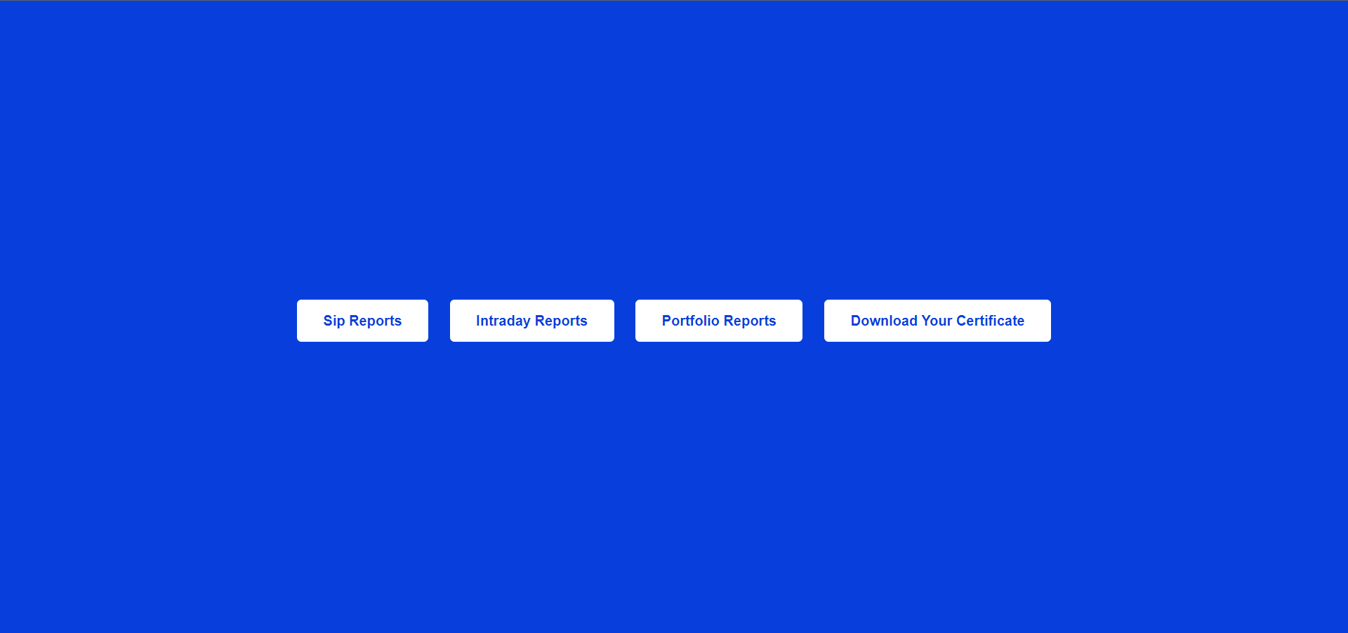

**5) Sip Reports :-**

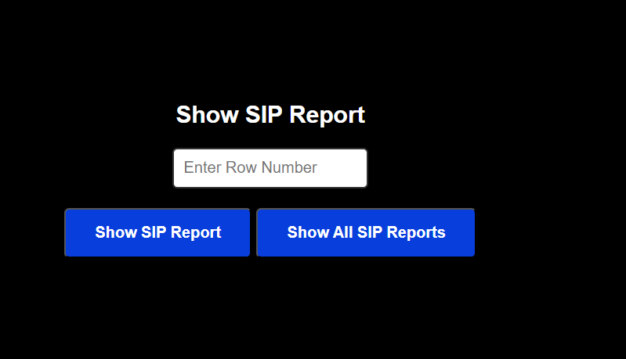

**6) Download Certificate:-**





**6) Trading Console:-**

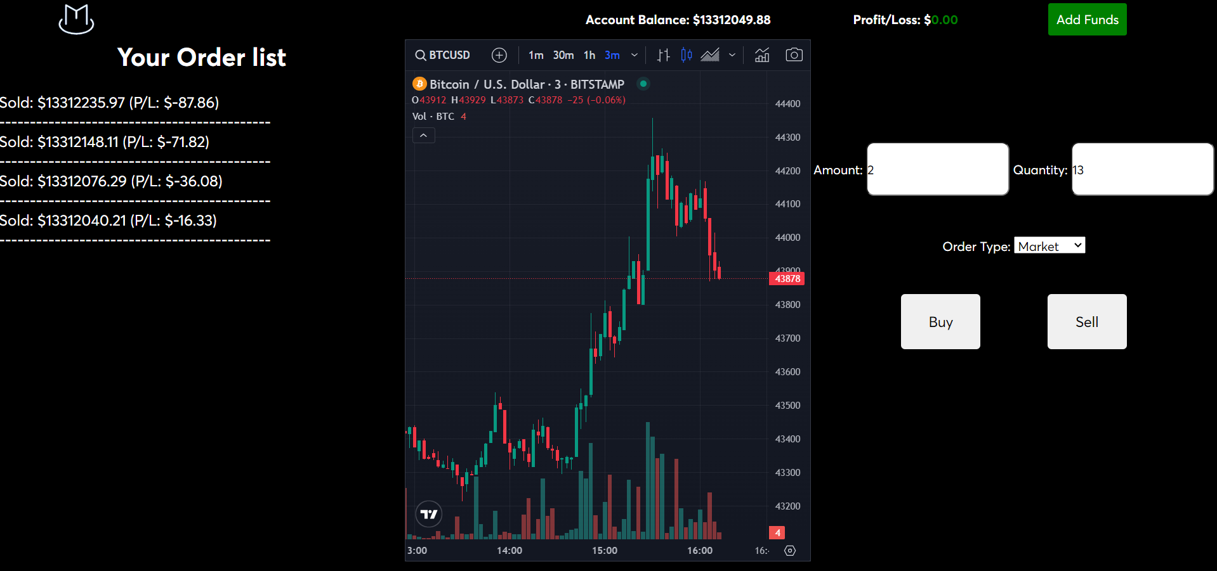

CHAPTER-XI

 **SYSTEM TESTING & IMPLEMENTATION** 

**SYSTEM TESTING:-**

**System testing and implementation are critical phases in the software development life cycle. Let's explore each phase:**

**System Testing:**

**1. Definition:**

**Objective: To ensure that the entire system works as intended and meets the specified requirements.**

**Scope: Involves testing the integrated system, including both functional and non-functional aspects.**

**2. Types of System Testing:**

**Functional Testing: Validates that each function of the system performs as expected.**

**Performance Testing: Assesses the system's responsiveness, scalability, and reliability under various conditions.**

**Security Testing: Checks for vulnerabilities and ensures that the system is secure against unauthorized access.**

**Usability Testing: Evaluates the user interface and overall user experience.**

**3. Test Cases and Execution:**

**Develop comprehensive test cases based on requirements.**

**Execute test cases systematically, logging and analyzing results.**

**Conduct regression testing to ensure new features do not break existing functionality.**

**4. Bug Tracking and Resolution:**

**Document and prioritize any issues or bugs discovered during testing.**

**Collaborate with the development team to resolve identified issues.**

**Perform re-testing to confirm bug fixes.**

**5. Acceptance Testing:**

**Involve stakeholders in user acceptance testing (UAT).**

**Ensure the system meets business requirements and gains user approval.**

**Implementation:**

**1. Planning:**

**Develop a detailed implementation plan, including timelines, resources, and potential risks.**

**Communicate the plan to all stakeholders.**

**2. Deployment:**

**Release the system into the production environment.**

**Monitor and manage the deployment process to minimize downtime.**

**3. Training:**

**Train end-users and administrators on how to use the new system.**

**Provide documentation and support resources.**

**4. Data Migration:**

**Migrate data from the old system to the new one.**

**Validate data integrity during and after the migration process.**

**5. Post-Implementation Review:**

**Evaluate the success of the implementation against predefined criteria.**

**Gather feedback from users and stakeholders.**

**Address any post-implementation issues promptly.**

**6. Maintenance and Support:**

**Establish a system for ongoing maintenance and support.**

**Monitor performance, address user concerns, and apply updates as needed.**

CHAPTER-XII

 **SUGGESTIONS & CONCLUSION** 

**Suggestions**:

User Feedback:

Encourage users to provide feedback during and after system implementation.

Consider implementing feedback mechanisms within the system for continuous improvement.

Training Programs:

Conduct regular training sessions for users to ensure they are proficient in using the system.

Provide additional resources like tutorials or documentation to support user learning.

Monitoring and Performance Optimization:

Implement robust monitoring tools to track system performance.

Continuously optimize system performance based on monitoring results and user feedback.

Security Measures:

Regularly update and patch security vulnerabilities.

Conduct periodic security audits to identify and address potential threats.

Scalability Planning:

Anticipate future growth and ensure the system can scale to accommodate increased user load or data volume.

Plan for regular capacity assessments and scaling exercises.

Documentation:

Maintain comprehensive documentation for both users and administrators.

Keep documentation up-to-date with any system changes or updates.

**Conclusion:**

In conclusion, the successful implementation of the stock broking website has been a collaborative effort involving meticulous planning, rigorous testing, and effective communication. The incorporation of user feedback and adherence to best practices in system testing and implementation has resulted in a robust and user-friendly platform.

The system provides a seamless experience for users to engage in stock trading, offering real-time market data, secure transactions, and a dynamic interface. The adherence to security protocols ensures the confidentiality and integrity of user information. The website's scalability and performance optimizations lay the foundation for future growth and sustainability.